**Chapter 3**

**Derivatives**

**3.2 The Derivative as a Function**

**Section Exercises**

**For the following exercises, use the definition of a derivative to find **

55. 

Answer: 

57. 

Answer: 

59. 

Answer: 

61. 

Answer: 

63. 

Answer: 

**For the following exercises, use the graph of  to sketch the graph of its derivative **

65.

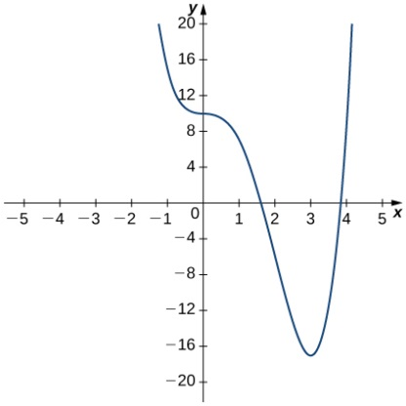

Answer:

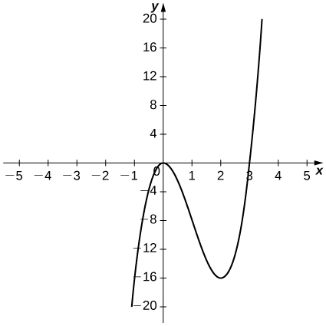

67.

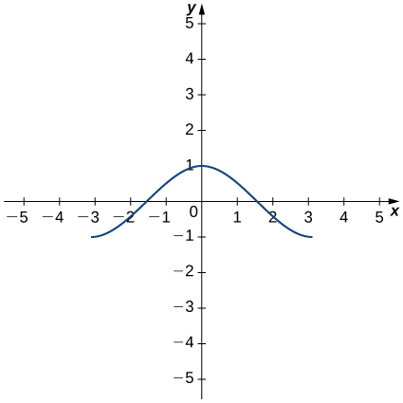

Answer:

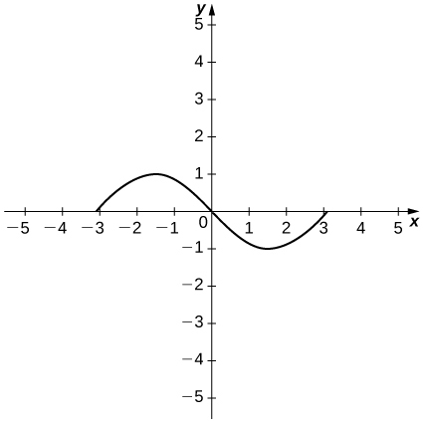

**For the following exercises, the given limit represents the derivative of a function  at Find  and .**

69. 

Answer: 

71. 

Answer: 

73. 

Answer: 

**For the following functions,**

1. **sketch the graph and**
2. **use the definition of a derivative to show that the function is not differentiable at **

75. 

Answer: a.

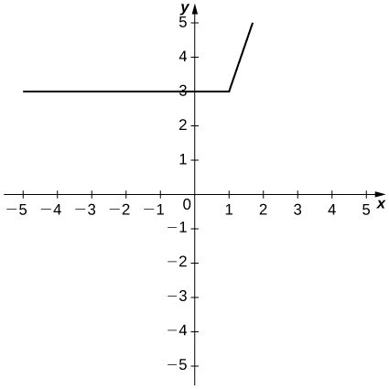

b. 

77. 

Answer: a.

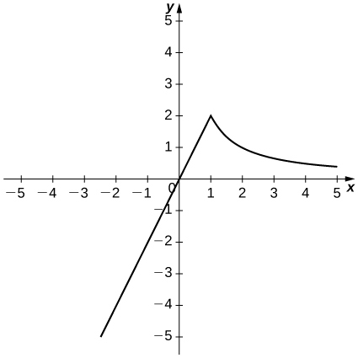

b. 

**For the following graphs,**

1. **determine for which values of  the  exists but  is not continuous at  and**
2. **determine for which values of  the function is continuous but not differentiable at **

79.

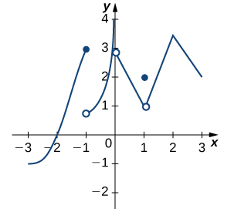

Answers: a. , b. 

**For the following functions, use  to find **

81. 

Answer: 

83. 

Answer: 

**For the following exercises, use a calculator to graph Determine the function then use a calculator to graph**

85. **[T]** 

Answer: 

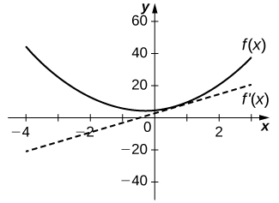

87. **[T]** 

Answer: 

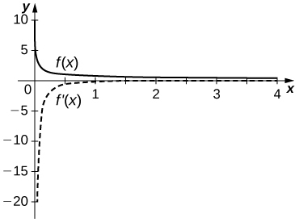

89. [**T**]

Answer: 

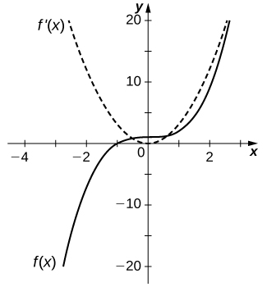

**For the following exercises, describe what the two expressions represent in terms of each of the given situations. Be sure to include units.**

1. 
2. 

91.  denotes the total amount of money (in thousands of dollars) spent on concessions by  customers at an amusement park.

Answer: a. Average rate at which customers spent on concessions in thousands per customer. b. Rate (in thousands per customer) at which  customers spent money on concessions in thousands per customer.

93.  denotes the grade (in percentage points) received on a test, given  hours of studying.

Answer: a. Average grade received on the test with an average study time between two values. b. Rate (in percentage points per hour) at which the grade on the test increased or decreased for a given average study time of  hours.

95. denotes atmospheric pressure at an altitude of  feet.

Answer: a. Average change of atmospheric pressure between two different altitudes. b. Rate (torr per foot) at which atmospheric pressure is increasing or decreasing at  feet.

97. Suppose temperature  in degrees Fahrenheit at a height  in feet above the ground is given by .

1. Give a physical interpretation, with units, of .
2. If we know that  explain the physical meaning.

Answer: a. The rate (in degrees per foot) at which temperature is increasing or decreasing for a given height .b. The rate of change of temperature as altitude changes at  feet is  degrees per foot.

99. The graph in the following figure models the number of people  who have come down with the flu  weeks after its initial outbreak in a town with a population of  citizens.

1. Describe what  represents and how it behaves as  increases.
2. What does the derivative tell us about how this town is affected by the flu outbreak?

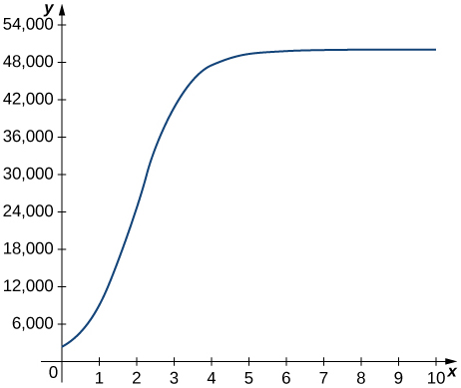

Answer: a. The rate at which the number of people who have come down with the flu is changing  weeks after the initial outbreak. b. The rate is increasing sharply up to the third week, at which point it slows down and then becomes constant.

**For the following exercises, use the following table, which shows the height  of the Saturn  rocket for the Apollo  mission seconds after launch.**

|  |  |
| --- | --- |
| Time (seconds) | Height (meters) |
|  |  |
|  |  |
|  |  |
|  |  |
|  |  |
|  |  |

101. [**T**] Construct a table of values for and graph both and on the same graph. (*Hint:* for interior points, estimate both the left limit and right limit and average them.)

Answer:

|  |  |
| --- | --- |
| Time (seconds) | (m/s) |
|  |  |
|  |  |
|  |  |
|  |  |
|  |  |
|  |  |

103. [**T]** The best quadratic fit to the data is given by where is the height of the rocket (in meters) and  is the time elapsed since takeoff. From this equation, determine Graph with the given data and, on a separate coordinate plane, graph 

Answer:

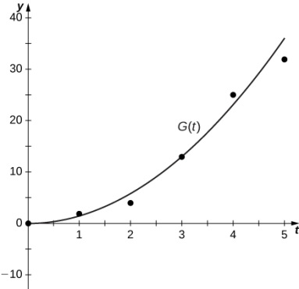

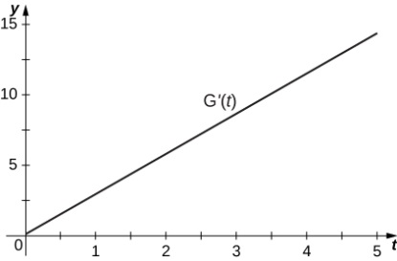

105. Using the best linear, quadratic, and cubic fits to the data, determine what are. What are the physical meanings of and what are their units?

Answer: represent the acceleration of the rocket, with units of meters per second squared ().

This file is copyright 2016, Rice University. All Rights Reserved.